**Creation of update set**

|  |  |
| --- | --- |
| **Team ID** | LTVIP2025TMID29041 |
| **Project Name** | Calculating Family Expenses |
| **College Name** | Kandula Lakshumma Memorial College of Engineering for Women |
| **Course** | Computer Science Engineering |

2.1 Creation of new update set

2.1.1 search for update set

* Go to All >> In the filter search for Local Update set
* Click on local update set

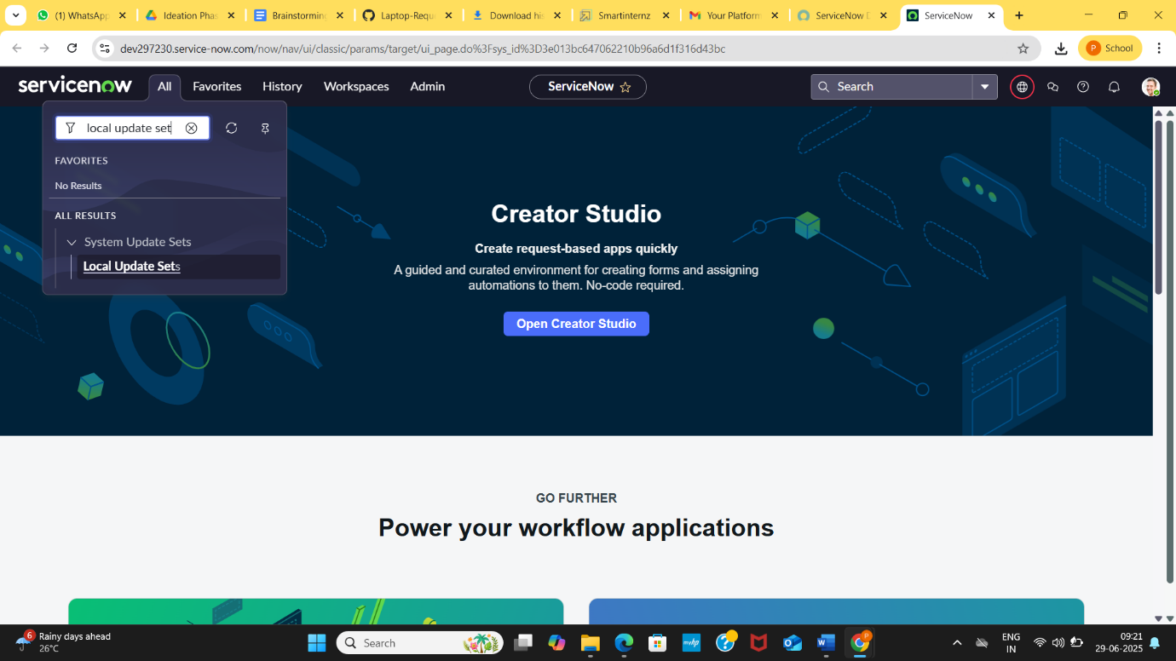

* After open the local update set Click on New

2.1. 2 Enter the Details as:

* Name: Family Expenses
* Then click on Submit and Make current.

